UniKL crush Maybank to march into TNB Cup final
www.sports247.my
February 28, 2019

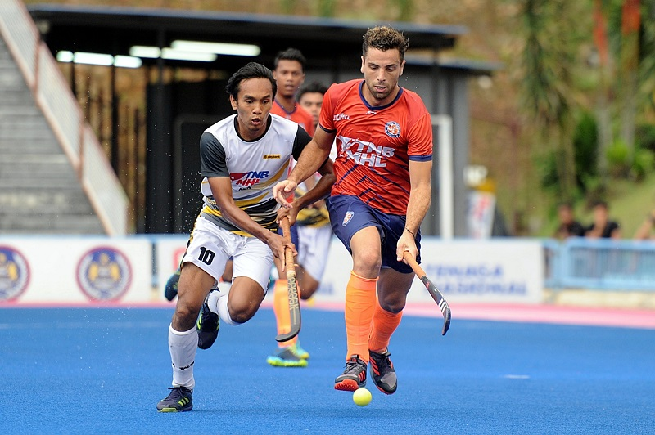

Universiti Kuala Lumpur (UniKL) and Terengganu Hockey Team (THT) qualified for the 2019 TNB Cup final at the Tun Razak Stadium.
UniKL, the 2019 League winner and defending TNB Cup champions, crushed Maybank 5-0 in the second-leg semi-finals today to move into Saturday’s final 9-1 on aggregate. UniKL won the first-leg semi-finals encounter 4-1 on Tuesday.
Muhammad Razie Abdul Rahim scored a brace through penalty corner conversions (30th and 50th minutes) while Dutch international Robbert Kemperman (35th), Muhamad Marhan Mohd Jalil (49th) and Faridzul Afiq Mohd (59th) added to the Tigers misery.
In an earlier match, THT defeated Tenaga Nasional Berhad (TNB) 5-2 in the second-leg semi-finals to advance to the final 8-3 on aggregate. The east coast state won the first-leg tie 3-1 at the same venue.
South Korean Jang Jonghyun scored all five goals via penalty corner conversions to take his personal tally to 21 goals in the league. TNB scored through Mohamed Akhimullah Anuar Esook (10th) and Faiz Helmi Jali (34th).
“We did not rush into the game today but rather paced ourselves well against Maybank after taking a 2-0 lead and the goals just kept coming in,” said UniKL coach Arul Selvaraj.
“The final will be exciting although we may not have four of our foreign signings from Europe. But I believe the players will know what is expected of them in such a situation,” he added.
Arul, who is down with fever and body aches, joined the team today after missing out in Tuesday’s first-leg semi-finals match due to illness. However, forward Muhammad Najmi Farizal Jazlan did not play today as he is nursing a wrist injury sustained against Maybank earlier.
Meanwhile, Terengganu coach I. Vickneswaran praised Jong-hyun for his superb goal scoring effort to help the team reach the final.
“Jang has improved in drag flicks as we have been working on penalty corners variants during training,” said Vickneswaran. “To me what is important is to play well and win the match. We are not to bothered with the aggregate as we have learnt our lesson in the Asian Games final match against Japan when we (Malaysia) took a 5-2 lead before the match ended in a draw (6-6) and we lost in the penalty shootout.”
“We played to our game plan and made use of our penalty corners well in the match,” said Vickneswaran.
Fixtures – Saturday (March 2, 2019) – Third-Fourth Placing: Tenaga Nasional Berhad vs Maybank (3pm). Final: Universiti Kuala Lumpur v Terengganu Hockey Team (5pm). both matches at Tun Razak Stadium.

