10th NOVEL RESEARCH AND INNOVATION COMPETITION (NRIC)
FACULTY OF PHARMACY AND HEALTH SCIENCES
On 16th August 2016, two final year students from Bachelor of Pharmacy programme participated in “10th Novel Research and Innovation Competition (NRIC)”, organized by Universiti Sains Malaysia (USM), Penang, Malaysia.

Both the participants along with Dr. Mahendran Sekar, advisor of the team started from Ipoh, Tasek campus on Tuesday (16th August 2016) at 11.00 AM and arrived at USM, Penang around 02.00 PM. The students were registered in the competition and housed in USM hostel. Around 05.30 PM, the organizer conducted briefing session which lasted around 06.30 PM.
We had our dinner and discussed about the preparation for the next day competition.

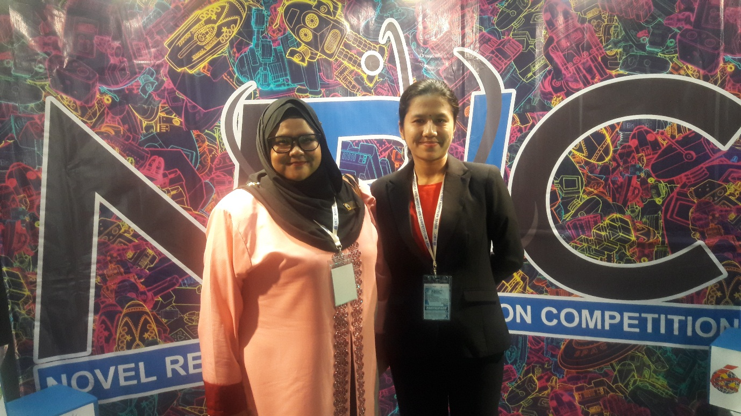

Next day morning (17th August 2016), after having our breakfast, we are attended opening ceremony. The event was officiated by Dato' Seri Idris bin Jusoh, Minister of Higher Education, Malaysia. This year “NRIC” competition attracted 111 projects from Various Universities in Malaysia, Thailand, Indonesia and India with the participants of more than 400 students. The judges were evaluated the projects based on the novelty, invention, creativity and commercial value of the products and its usefulness and application to overcome the current situations.
We have participated under “Community Research and Innovation Competition (CoRIC)” category. CoRIC is a viva-oriented competition, in which requires the participants to present their ideas of how to make a better world in front of judges. The team with the most captivating idea will then be granted with capital to make their idea a reality. The judges including representative from the community, academician, and also representative from industries.
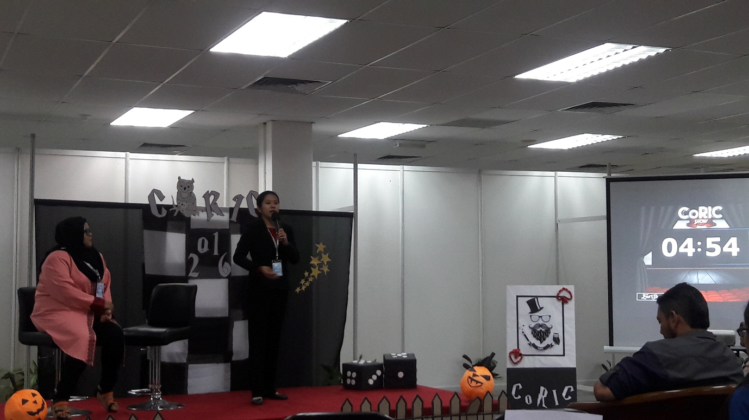
Our students (Pavitra Sivalinggam and Noor Jasmin Binti Shamsul Ariffin) made a good presentations in CoRIC show. All the judges were appreciated our student’s project and their presentation. Later, the exhibition was started and all the students were displayed their innovative products attractively. The first day exhibition was ended at 5.00 PM.

The next day (18th August 2016), exhibition was continued and opened for public view. Finally, the exhibition was closed at 2.00 PM. All our students enjoyed the competition and took the opportunity to make friendship with their contestants from other Universities.
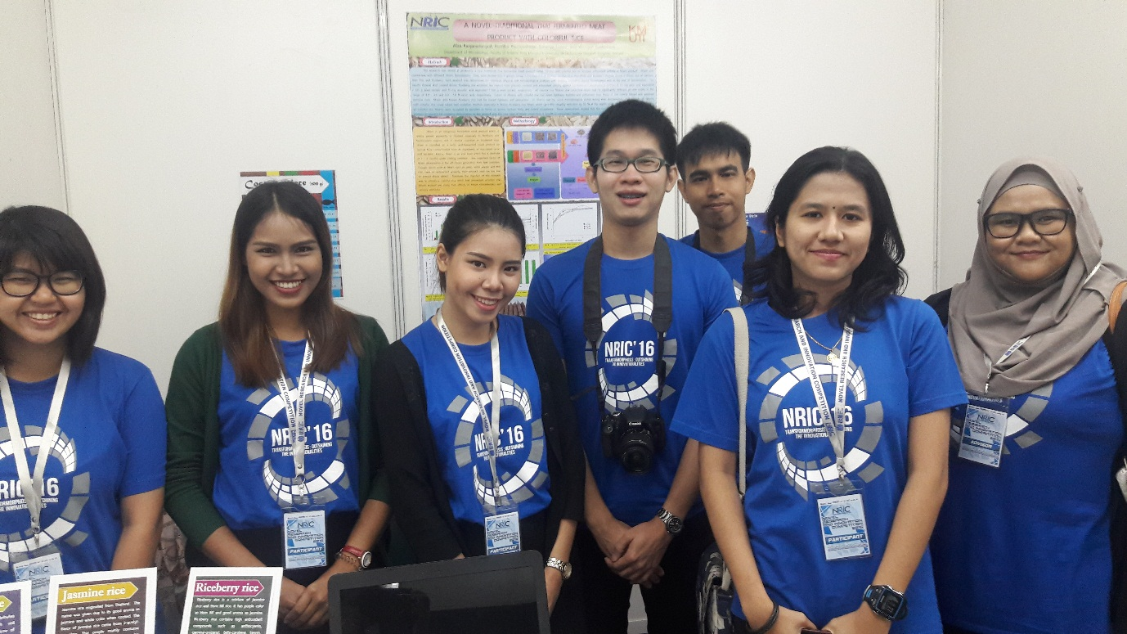
After that, the prize giving and closing ceremony was held at Georgetown City Hotel. It was officiated by Prof Dato’ Dr. Omar Osman, Vice Chancellor, USM, Malaysia. This was the most awaited moment of the competition. The winner of the 10th NRIC Competition was the team from King Mongkut’s University of Technology Thonburi (KMUTT), Thailand. Also the winner of CoRIC was the team from Universiti Malaysia Terengganu.
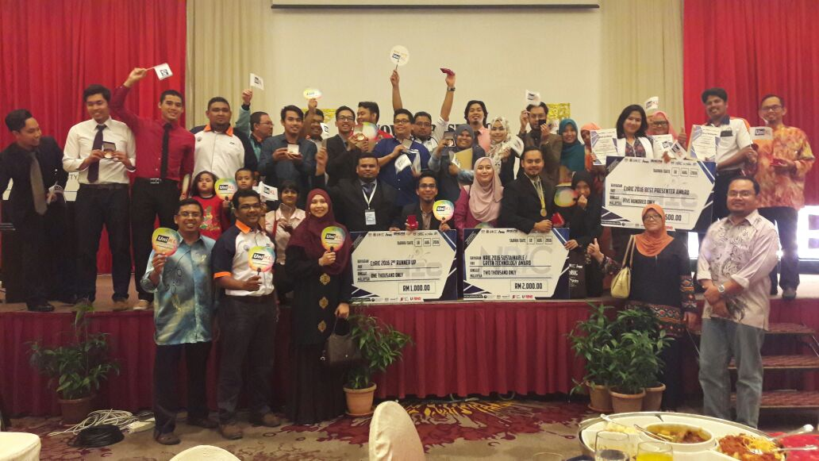

PAVITRA SIVALINGGAM (UniKL-RCMP), received “BEST PRESENTER AWARD” under CoRIC category for the project entitled “Formulation and evaluation of novel antiaging cream containing Rambutan fruits extract”
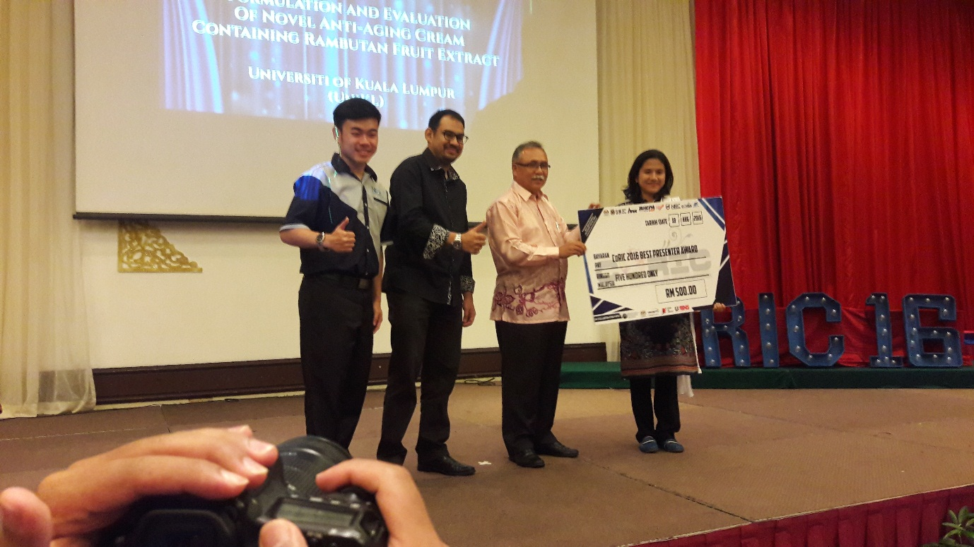
After the prize giving ceremony, we had dinner and took opportunity to take photographs with VIP’s and participants from other campuses.
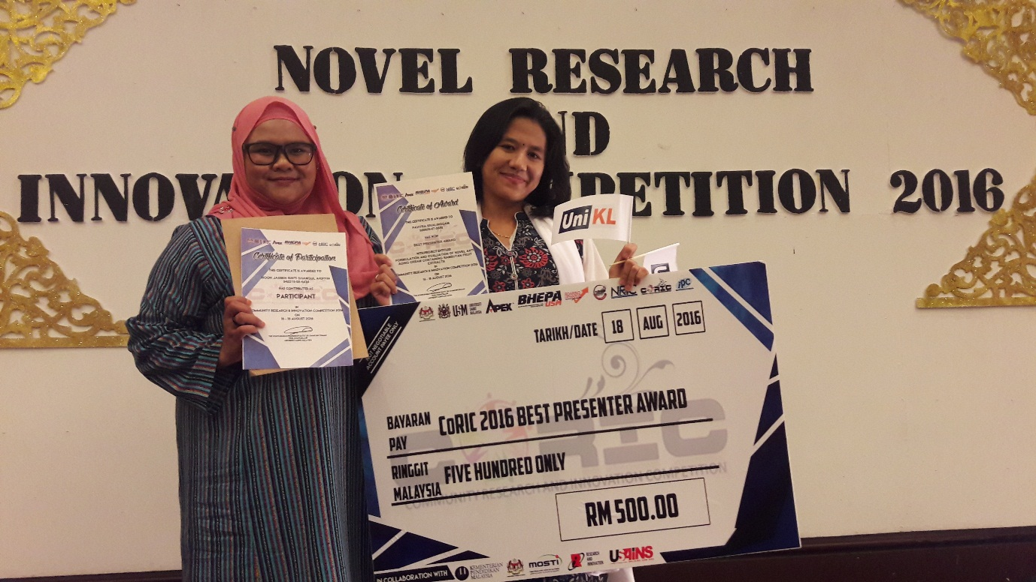
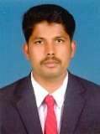
It was a great competition and the students had a good time in USM campus. This competition encouraged the students to become more innovative and good entrepreneurs in future to support the needs of the nation. This competition also increased the level of confidence in our students.

Dr. Mahendran Sekar
Senior Lecturer, FPHS, UniKL-RCMP

