Why distance learning gets a bad name from false credentials
Rais Hussin | Published: 17 Mar 2019, 10:06 am | Modified: 17 Mar 2019, 10:06 am
Malaysiakini(www.malaysiakini.com)

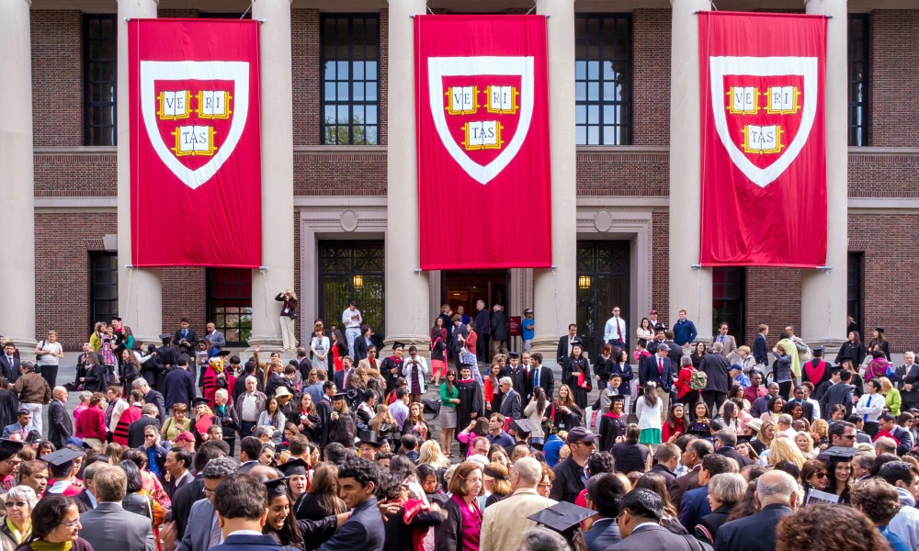

Distance learning is not rocket science. It has been around perhaps since the external degree programmes of the University of London. The various colleges in the University of London would conduct some of their simplest courses abroad, when Britain was at the apex of its power, "ruling over the seven seas," as the adage went, but hosting them in local colleges throughout the Commonwealth.
Distance learning, in other words, can have a pedigree that goes back by 200 years, if not earlier.
Kaplan University and University of Phoenix, even Norwich University in the US, have had successful online courses. A PhD in Social Work at the prestigious University of Southern California (USC), one of the most expensive colleges in the West coast of the United States, can be done all online.
Columbia University has an MA degree in Sports Management that can be pursued totally online too; as is Johns Hopkins University that offers such pathways in BA, MA and MSc.
If degrees are not your cup of tea, one can do short five- or six-week courses at EdX.org which was pioneered by Harvard and MIT.
If one crosses the causeway, the Emeritus Institute in Singapore offers short but impactful diplomas from Columbia University, MIT and Dartmouth College, all on the cheap.
In Japan, pursuing a certificate at the University of Tokyo, is not an impossibility, even if one does not speak Japanese. The course "Visualising Post World War II Tokyo," has been archived by Edx.org.
At Harvard, if one cannot afford an MBA, taking a course on disruptive technologies with professor Clayton Christensen, one of the most renowned professors in the world, can all be done online. One must have the discipline and stamina to pursue the courses, when the time is reversed, as it is night time in Malaysia and day time in the US.
Indeed, if one cares to Google Ivy League Central, there is a huge array of top courses that can be undertaken by students from all over the world. In some cases, such as Harvardxedu, some six MBA courses have been accepted as the core equivalent of any businesses courses done in the class.
At Stanford, many online courses are executed in collaboration with Coursera. That does not include other top state and private universities in California and elsewhere.
When you pass the certificates or degrees, a block chain of numbers and serials are assigned. When an employer wants to assess the authenticity of your credentials, they just type the numbers and assigned alphabets into the university search engines. And, voila, you are either an authentic or fake graduate.
Those who are guilty must own up
The problem with some politicians who carry fake credentials is their ostensible belief that they cannot be caught with their pants down. But Cambridge International University in the US, is indeed not the University of Cambridge in the UK.
To the degree one wants a credential from the genuine University of Cambridge, for that matter University of Oxford, their departments of continuing education offer real online enrollment, that leads to actual accreditation and completion.
At Harvard, if you cannot complete a course at the extension school, which has an online arm, you are banned forever; subject to future appeal.
With the proliferation of authentic online courses, short or long distance courses need not be used as a false education credential. Any shoddy attempt to do so shows a lack of understanding of the power of online courses, the blockchain, and e-learning. Now, this leads to the impact on the structural integrity of Bersatu.
If senior members of Bersatu can get away with murder, then it has a ricochet effect on the Rural Development Ministry, which oversees tens of thousands of students of Mara and University of Kuala Lumpur too.

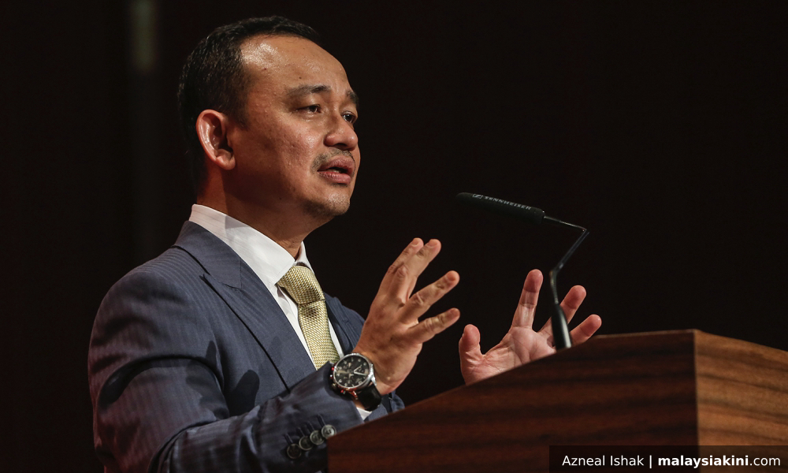

The Education Ministry, after all, is under Maszlee Malik (photo). Maszlee has explained in Parliament that University of Tsukuba of Tokyo is opening a branch in Malaysia.
If Bersatu has representatives or leaders whose academic credentials cannot be vouched for, how can the likes of Japan, which according to Francis Fukuyama is a "high trust society," which operates in most cases on total honour, believe what Maszlee has to say?
In turn, if the effects of sweeping everything under the party carpet continues, it would be Prime Minister Dr Mahathir Mohamad who would be imposing his authority on all the academic and non-academic indiscretions from top to bottom.
At that rate, Mahathir would not only be drained, but the moral energy of Pakatan Harapan would be gradually vacuumed.
The clear beneficiary would be PAS and Umno who have even less credentials to project themselves in any light.
Is that what the trail of false paper qualifications online must lead to? A meltdown of Harapan?
"Siapa makan cili, dia yang harus rasa pedas," goes one saying. Those who are guilty must own up. Bersatu has to set the right example. The fish rots from the head first.
If this fiasco is not set straight now, even the negotiations with Singapore would be affected, as the Foreign Affairs Ministry would not be seen with any gravitas.

