Quality affected due to disparity between top and lower teams
Monday, 4 Mar 2019
www.thestar.com.my

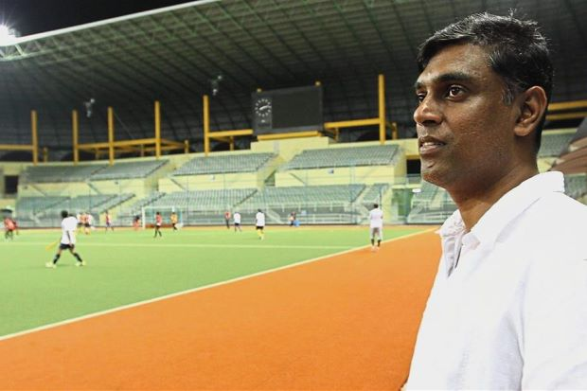
Shocked: UniKL coach Arul Selvaraj is surprised that Maybank players came down with cramps during the league

PETALING JAYA: The dust has settled, but some wished the Malaysian Hockey League (MHL) could have been better.
The MHL ended on Saturday with Terengganu winning the TNB Cup and Universiti Kuala Lumpur (UniKL) bagging their first league trophy but there was criticism over the handling of the tournament and the small number of teams involved.
Also, the gap between some teams was evident as top teams scored big wins over teams who did not have the quality or services of foreign players.
UniKL head coach Arul Selvaraj said the disparity between top clubs like UniKL, Terengganu and Tenaga Nasional and other sides like TNB-Thunderbolt, Maybank, Universiti Teknologi Mara (UiTM) and Nur Insafi was huge.
“The gap in standard is too great. Some teams don’t have the calibre and also foreign players to back them up. Tenaga have so many national players, and our side have a few well-known foreigners. That’s why we could sustain it in the league,” said Arul.
“I can’t blame Nur Insafi because they don’t have many quality players. However, they have the guts to put up a team. UiTM did the same.
“The Malaysian Hockey Confederation (MHC) must think and plan for the future. The league has to be better,” he said.
He pointed out that some players were not fit to play in the league.
“I was shocked to see four to five players from Maybank floored due to cramps. I’ve played for Maybank in the past, and the team used to have really fit players,” he said.
“The quality of matches are affected when teams don’t have players with calibre.”
Terengganu coach I. Vickneswaran, however, commended the MHC for organising the league although they had a bigger focus – to get the national team to qualify for the 2020 Olympic Games in Tokyo.
“The league is fundamental for the growth of hockey in Malaysia. In the yesteryears, the league would have taken a break if the players had national duty,” he said.
On the fewer teams in the league, Vickneswaran said that having many teams would only widen the gap in quality.
“The standard will be different. If we want to have more teams, we must encourage each state government to form a team for the league. Terengganu have done that, and they are very supportive of hockey development,” he said.
He, however, suggested that the league should be held longer.
“Instead of holding the league in the span of two months, they can do the league in four months and divide them into two parts. There’s a window in the middle to change players. This would make the league more interesting and exciting.”
Tags / Keywords:Malaysia Hockey League

