Terengganu HT bank on Korean firepower to thrash Tenaga
New Straits Times
Friday, 1 March 2019, 12:28 PM

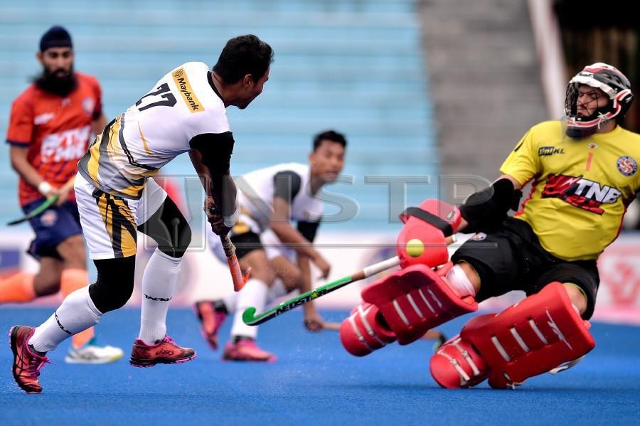

By Jugjet Singh
February 28, 2019 @ 10:42pm

KUALA LUMPUR: Terengganu Hockey Team’s (THT) South Korean Jang Jung Hyun single-handedly demolished Tenaga Nasional with five goals in the semi-final second leg of the TNB Cup earlier today (Thursday).
Terengganu HT, who won the first leg 3-1, hammered Tenaga 5-2 for an 8-3 aggregate win.
In the other semi-final, Universiti Kuala Lumpur (UniKL) beat Maybank 5-0 for a 9-1 aggregate win.
UniKL and Terengganu HT will square off for the TNB Cup on Saturday (March 2).
Tenaga started strongly, and it looked like they were ready to reverse the first leg score when Akhimullah Anuar Esook scored off a penalty corner rebound in the 10th minute.
However, Jang had other plans as he scored five penalty corner goals in the 14th, 15th, 32nd, 52nd and 53rd minutes.
The other Tenaga goal was scored by Faiz Helmi Jali in the 34th minute.
Jang is the tournament’s top-scorer with 21 goals. He also top-scored with 28 goals in the 2017 season.
“It is always nice to help my team win any match but today was special as I managed to score five. In the final, I believe I can contribute at least another two or three goals,” said Jang.“Even though we had a two-goal cushion, we did not take our foot off the pedal, and with Jang in form, we managed to win by a big margin,” said Terengganu HT coach I. Vikneswaran.
National coach Roelant Oltmans said: “Tenaga had their chances and played well, but Terengganu made sure with their penalty corners and that separated both the teams.”

