Cover Story: Building a sense of neighbourliness

Wong King Wai
/
The Edge Malaysia
April 01, 2019 16:00 pm +08
https://www.theedgemarkets.com/article/cover-story-building-sense-neighbourliness
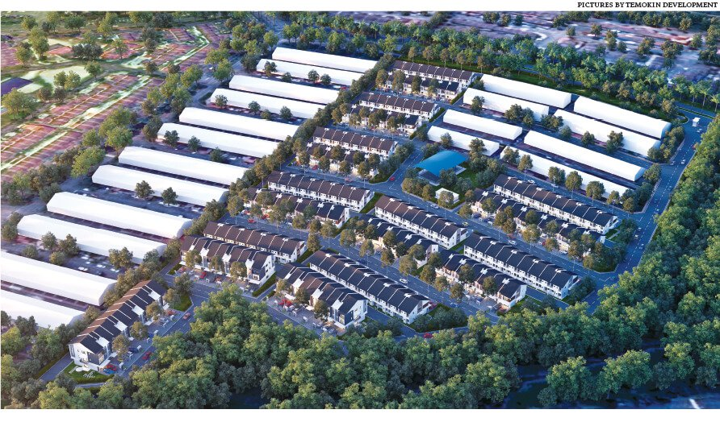
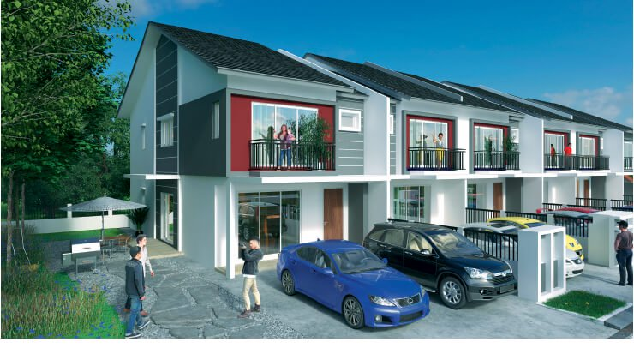
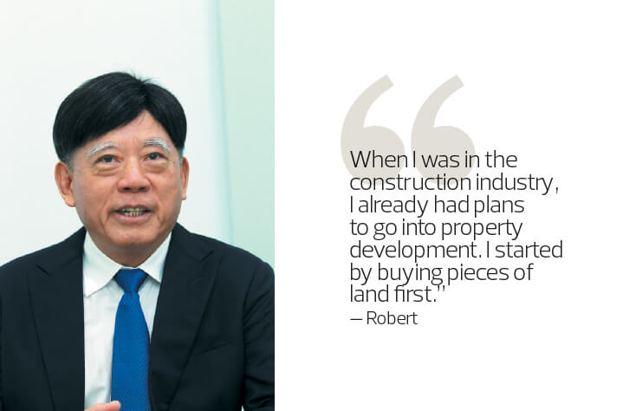
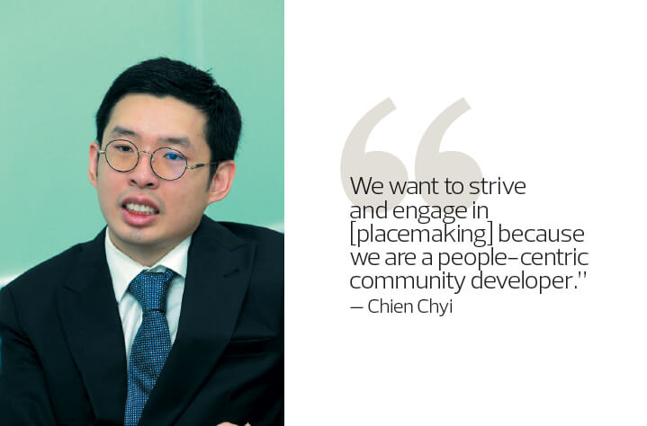
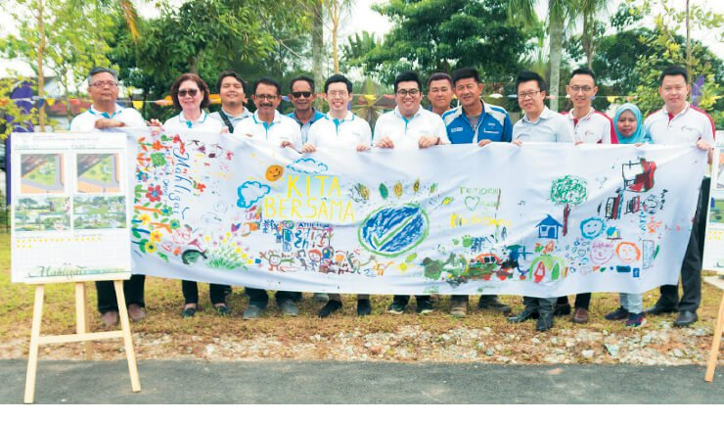

A chance meeting could change one’s life. For Temokin Holdings Sdn Bhd group executive director Datuk Robert Tan Kim Kuan, the serendipitous event occurred when he first arrived at Universiti Malaya in the early 1970s.
“In those days, there was no professional career guidance. I only knew the professions of teaching, medicine and law enforcement,” Robert recalls with a smile. “Being a doctor or policeman was out, so I signed up at the science faculty in Universiti Malaya [to be a teacher]. After that, a friend of mine looked at my results and said why don’t I try engineering?
“I asked him what an engineer did and he explained it to me. He said engineers construct houses for people to stay in and build roads to get people from one point to another; which I considered noble work. So, instead of going to the science faculty, I went to the engineering faculty. I changed my major and it was God’s guidance.”
Robert graduated in 1974 with a degree in civil engineering and started his career in the government sector. After 2½ years, he moved to a consultancy and stayed a further 2½ years before joining YTL Construction, where he rose through the ranks to become chief engineer.
In 1990, with a young family, he decided to strike out on his own and founded Temokin Holdings Sdn Bhd. “After 14 years of working for people, I felt I was ready to start my own company. First, I wanted to challenge myself to see how much I could do and, second, I needed more money to feed my family,” he says with a chuckle. “I set up Temokin Holdings with a capital of RM35,000. We then got three Tenaga Nasional substation projects. We did earthworks for Perbadanan Kemajuan Negeri Selangor (PKNS), a highway in Klang for Lembaga Lebuhraya Malaysia and a sewage project for PKNS.”
The company continued to do well in the 1990s and survived the Asian financial crisis. “In 1997, when the crisis came, I bought a RM2 million microtunnelling machine from Japan. I got two projects, which was more than enough to cover my cost,” says Robert. The mix of private and government projects involved companies such as Dialog Group Bhd, Puncak Niaga Holdings Bhd and Dewan Bandaraya Kuala Lumpur. Microtunnelling, also called pipe jacking, uses smaller drills to build underground pipelines, ducts and culverts.
Two of his four children — three boys and a girl — became engineers. One of them is his youngest son, Chien Chyi, who is the director of the company’s property development division, Temokin Development Sdn Bhd. “I took up engineering because I had grown up going to work sites and construction sites. I think that exposure showcased that engineering is a good foundation,” he says. “I didn’t think I could do pure engineering, so I moved into property development, which is a natural progression from engineering.”
Robert agrees with his son and believes that the communal element of construction marries well with property development. “Construction is very communal. We construct roads for people to go from one point to another, we construct bridges for people to cross rivers, flyovers to ease traffic congestion and channels to supply water to households. We help deal with sewage before it goes into the rivers,” he explains.
The move into property development was always a goal for Robert but he held back until 2011, when he incorporated Temokin Development. “When I was in the construction industry, I already had plans to go into property development. I started by buying pieces of land first.”
He bided his time until his children had graduated and he encouraged them to work in the family company. “For a company to continue, you must inject new and young blood to make it vibrant. I decided to start the property development division but we took two to three years to learn about the industry before launching our first project.”
Products that create a community
Temokin Development wants to come up with products that help create a community feeling through greater engagement. Placemaking — the approach of planning, designing and managing public spaces for the wellbeing of stakeholders — is an integral part of this vision.
“We always operate from our group values of ‘WE DIG’, where W is wisdom, E is equality, D is diligence, I is integrity and G is guidance. So with all this, it sparks a communal aspect in our DNA. We want to be a community-based property developer,” says Chien Chyi.
Temokin Development’s maiden project — the freehold Mahligai in Nusa Damai, Pasir Gudang, Johor — sits on 11.5 acres and has a gross development value (GDV) of RM100 million. The land was purchased in 2014 for RM10 million or RM35.80 psf.
“The surrounding areas are developed and mature. Somehow, the owner of the land, a developer, decided to sell it,” explains Robert.
“We named our maiden project Mahligai because the word is Sanskrit for ‘mansion’ and we believe that anyone who buys our product will be able to come home to and enjoy their own mansion,” says Chien Chyi.
Robert adds, “Mahligai is also a Malay word. I asked my Malay business partner, who said, to him, it means ‘heaven’. And in heaven, you get peace. So I said ‘Okay, we will go with this name [for our first project].”
The development is divided into three phases, says Chien Chyi. “We are launching the development in phases so that we can develop something better [in each phase], to give our buyers a better product. From Phase 1, we collected feedback from buyers, and we have incorporated them into the design of Phase 2.
“The target market is Johoreans, a localised market, and first-time homebuyers. The product is uniquely priced and very strategically located. We’re happy to say that 80% of Phase 1, which we launched last year, has been taken up and most of the buyers were within our target market,” he says.
Launched last Sept 25, Phase 1 consists of 53 two-storey terraced houses. The 20ft by 70ft homes with built-ups of 1,679 to 1,752 sq ft were priced from RM562,000, or RM368 psf on average. The targeted handover is April 2020.
Phase 2, scheduled to be launched next month, features 87 two-storey terraced houses. The 20ft by 70ft homes with built-ups of 1,759 to 1,802 sq ft will have indicative prices starting from RM593,000, or RM393 psf on average.
“For security, we have incorporated a guardhouse and are seeking approval from the local council to fence up certain areas to prevent outsiders from entering,” says Chien Chyi.
Mahligai will boast of three parks — two larger parks and a pocket park — for residents to enjoy. To create a sense of ownership of these green spaces, Temokin Development has embarked on a placemaking initiative called Kita Bersama. One of its first engagement activities is to gather views from future residents of Mahligai — buyers of Phase 1 as well as prospective buyers — of what they would like to see incorporated in the larger parks, after which a vote will be taken.
The pocket park will be landscaped by the developer as it is a small plot. “This is not a strata development but one with individual titles. So we wanted to give the buyers and the local council easy-to-maintain but effective landscaping and practical green space,” says Chien Chyi.
After the 11.5 acres are fully developed, the common spaces will be handed over to the local authorities to maintain.
No launch date has been set for the last phase but Chien Chyi reveals that the homes will be larger at three storeys and have direct access to the green spaces.
The development is accessible via the Pasir Gudang Highway and Senai-Desaru Expressway. Education centres in the vicinity include Sultan Ibrahim Premier Polytechnic Johor Bahru, Universiti Kuala Lumpur Malaysian Institute of Industrial Technology, UniWorld International School and The Japanese School of Johor. Mydin, Tesco and Maslee Pasir Gudang Supermarket among others will cater for residents’ grocery and other household needs. KPJ Pasir Gudang Specialist Hospital, Penawar Hospital and Regency Specialist Hospital are also nearby.
Developing a presence in the Klang Valley
The Tans will incorporate their placemaking initiatives in future developments. While it is a good idea, will it be possible to replicate it in other places as it requires plenty of engagement and planning?
The Tans are up to the challenge. “Doing something like this [placemaking] isn’t easy. Building highways, tall buildings and so on is not easy. From a construction point of view, nothing is easy,” Chien Chyi says. “So, mirroring that in development, there are so many factors that are not easy. But we want to strive and engage in [placemaking] because we are a people-centric community developer. In whatever development we do, we want to embrace that factor.”
Currently, the developer has a land bank of 50 acres, which is spread over the central region of Peninsular Malaysia.
“We are launching a project this year in Taman Melati, Gombak — a freehold development on 2.2 acres. We are looking to build 24 landed superlink homes. Built on Malay Reserve land, the houses will be 24ft by 123ft with a built-up of 3,000 sq ft,” says Chien Chyi.
“The key aspect is that 12 units will have a dual-key concept. This is because of the maturity of the area and the project’s location near the Gombak LRT station. We’ve found that there is potential capital appreciation for homeowners who want to rent out their second space or keep it for a family member.”
The selling price is yet to be set but the estimated GDV is RM40 million. The Tans plan to launch the project in 2H2019.
Also in the pipeline is a joint-venture project with Tropicana Corp Bhd on a 2.28-acre freehold parcel located near 3 Damansara in Petaling Jaya. The JV, which will most likely feature a high-rise block, was signed on Sept 27 last year.
For now, Temokin Development’s focus will be on the central and southern regions of Peninsular Malaysia and it will bide its time to develop its remaining land bank to ensure that it meets the needs of the market.

