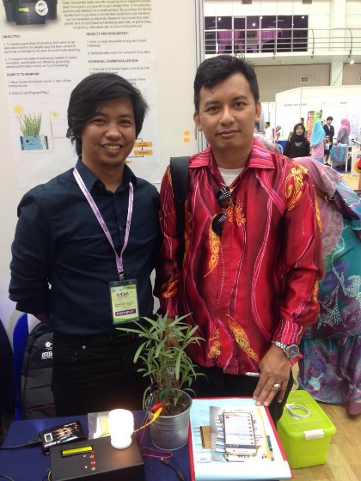
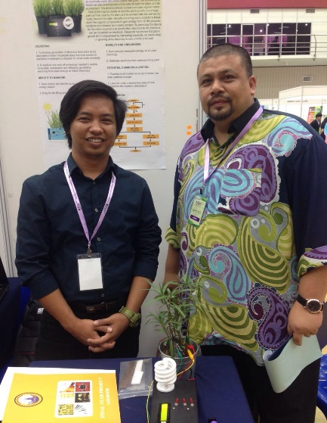
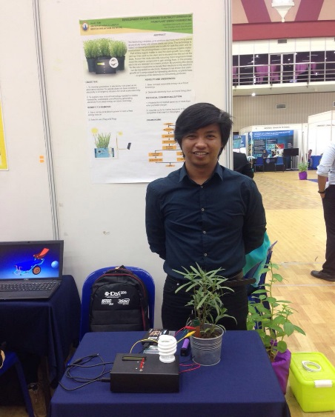

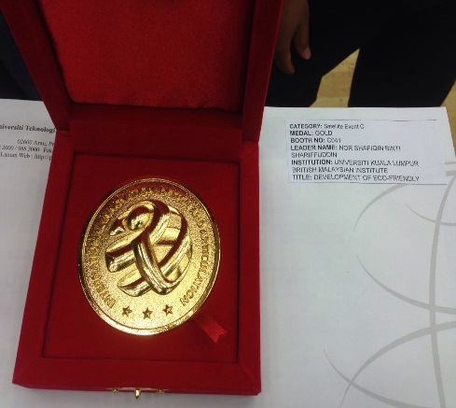
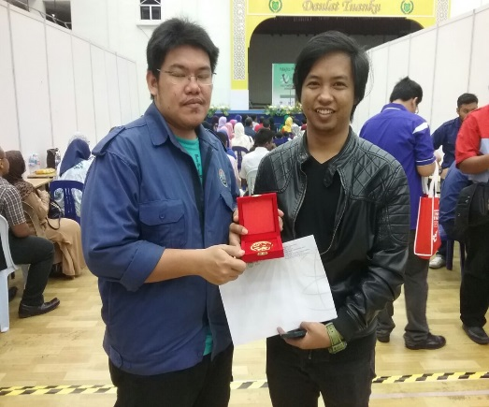
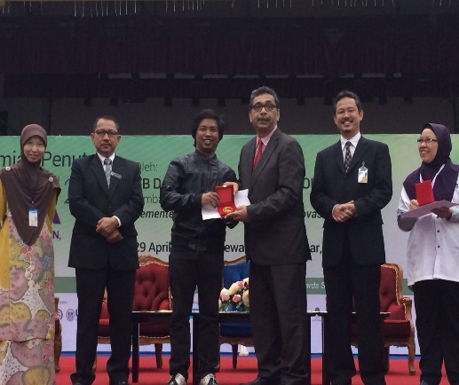

Event name : The 3rd International Innovation, Design and Articulation (i-IDeA 2016)
Date : 27 – 29 April 2016
Venue : Dewan 2020, Kangar Perlis
Project Title : Development of Eco-Friendly Electricity Generation from Plant Energy Harvesting
Team Members : Shahfizan Nasriq Bin Ali, Hazwan Zulfadhli Bin Mohd Sobri, Nor Shafiqin Binti
Shariffuddin
Award : Gold Medal

