Mara Edu aims to attract people
Published on: Sunday, March 17, 2019
dailyexpress.com.my

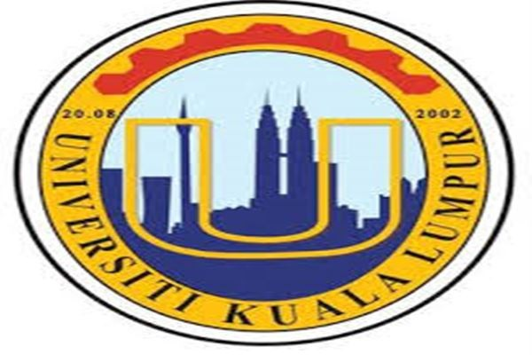

KUALA LUMPUR: The Mara Educational Institution (IPMA) aims to attract 250,000 visitors to its carnival this year, which is being held at 15 locations nationwide from today until April 15.
Universiti Kuala Lumpur (UniKL) president Prof Datuk Dr Mazliham Mohd Su’ud (rpt: Su’ud) said the carnival was aimed at exposing and providing information on opportunities available 10 IPMA in the country for those intending to further their studies.
“There are many opportunities and programmes at IPMA that many people do not know...for those with excellent results, they can opt for the preparatory programme for overseas studies at GMI (German-Malaysian Institute) and UniKL.
“Those with not so good results in SPM (Sijil Pelajaran Malaysia), IPMA has skills programmes, as being offered at IKM (Institut Kemahiran Mara) and GiatMara,” he told a media conference in conjunction with the carnival at Medan Mara here today.
Mazliham said at the carnival, visitors could apply and be offered directly to pursue their studies, in fields depending on their eligibility and qualification, by Majlis Amanah Rakyat (Mara), the National Higher Education Fund Corporation PTPTN) and several other agencies.
He said IPMA, which offers more than 400 study programmes at certificate, diploma and bachelor’s degree levels, aimed to get more than 25,000 students to enroll at its institutions this year.
The IPMA carnival is jointly organised by the Mara Poly-Tech College,Mara Professional Colleges, Mara Skills Institute, Mara Advanced Skills Colleges, Mara Colleges and Mara-Japan Industrial Institute, with UniKL as the main organiser.
The carnival is also held at Anggerik Mall in Shah Alam, Karamunsing Complex in Sabah, Maktab Mahmud in Alor Setar and Larkin Plaza in Johor Bahru. – Bernama

