UniKL ‘bury pain’ and look towards next season
- By Sports247.my

- Updated: March 4, 2019
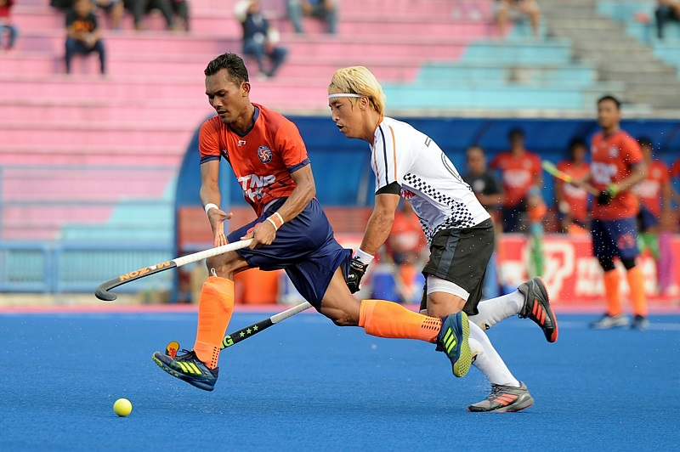

Universiti Kuala Lumpur (UniKL) painful 2-1 defeat by Terengganu Hockey Team (THT) in the 2019 TNB Cup final saw the defending champion’s chase for a second consecutive coveted trophy go up in smoke on Saturday.
It was the first cut for UniKL but the deepest and most shattering.
Just 10 days earlier UniKL claimed the Premier League title for the first time since making their debut in 2009 with an unbeaten record of 11 wins and a 2-2 draw against THT in the Charity Shield at the Batu Buruk Hockey Stadium in Kuala Terengganu.
The absence of Dutch internationals Martijn Peter Havenga, Robbert Kemperman, Valentin Verga as well as Ireland captain and goalkeeper David Harte in the final also served as a terrible blow to UniKL.
The ‘fabulous four’ were restricted to play in the Malaysian League until February 28 – the window set by the European Hockey Federation (EHF) for all European players competing in foreign tournaments as they are scheduled to play in the Dutch League in early March followed by the EuroHockey League knock-out stage in April.
Kemperman, Havenga and Harte play for SV Kampong. The club based in Ultrecht and was formed in 1902 – making it the second oldest hockey club in the Netherlands. Verga, however, represents Amsterdam.
Team manager Dato’ Amir Azhar Ibrahim said the painful episode of not having the Dutch players and Harte in the final is something they need to chew on with a tinge of sadness.
“We only discovered about the EHF ruling when David (Harte) told us on arrival on January 10. It was already too late to request the competition committee to adjust the fixtures as the League had already started with Tan Sri P. Alagendra Cup,” he said.
“But that is in the past now and we look towards a better season next year. We have good relationship with SV Kampong for our next plans. Off course having Kemperman, Havenga, Verga and Harte again is our priority.
“But it all depends on Netherland’s national team programme since 2020 is an Olympic Games year,” added Dato’ Amir.
UniKL picked up a handsome purse of RM160,000 in total prize money from both leagues.
The Tengku Abdullah Hockey Stadium in Bangi – home of UniKL, added Dato’ Amir, will also undergo several renovations. The blue pitch will be repaired and stadium lights improved. A bigger electronic scoreboard will also be installed as the current scoreboard is just a temporary measure.
Meanwhile, UniKL coach Arul Selvaraj has called on the ‘authorities’ in this case the Malaysian Hockey Confederation (MHC) to schedule the dates of the national league in advance.
“I beg MHC to plan in advance the league. When is the 2020 league so every team can plan in advance including hiring of foreign players? The league belongs to Malaysian Hockey and only seven teams are contributing this year,” lamented Arul.
“If more teams withdraw there is no hockey for Malaysia! So MHC must understand that and please support the clubs in our preparations. Please inform the closing date earlier,” said Arul. “EHF says after February 28 players cannot play in foreign leagues and we have to abide by their rules. They are very strict about it.
“MHC has to be strict in rules and do the same as EHF. For example if the closing date for registration of players in the Malaysian League has been set that’s it. Stick to it and no more changes. Here we keep extending to new dates and this does not help at all,” said Arul who has been coaching UniKL for seven seasons.
For now, UniKL will be relishing the sweet memories of the 2019 Malaysian hockey League.

